Lab 2

Title:
To develop a web page containing user registration form and implementing styles using inline, internal and external CSS

1. Objective:
The objective of this lab work is to design and develop a user registration form using HTML and apply styling using three different types of CSS: inline CSS, internal CSS, and external CSS. This lab helps to understand the difference and usage of each CSS method.

2. Tools / Software Used:
- Operating System: Windows / Linux / macOS
- Text Editor: VS Code / Notepad++ / Notepad
- Web Browser: Google Chrome / Mozilla Firefox

3. Theory:
A user registration form is a common web component used to collect user information such as name, email, password, and gender.
CSS (Cascading Style Sheets) is used to style HTML elements. There are three types of CSS:
- Inline CSS: Applied directly inside an HTML element using the style attribute.
- Internal CSS: Defined inside the <style> tag within the <head> section of an HTML document.
- External CSS: Written in a separate .css file and linked to the HTML document using the <link> tag.
Using these three methods helps understand how CSS can be applied at different levels.

4. Algorithm / Procedure:
- Create an HTML file for the registration form.
- Create a separate CSS file for external styling.
- Define internal CSS inside the <style> tag.
- Apply inline CSS directly to specific HTML elements.
- Add form elements such as input fields, radio buttons, and submit button.
- Link the external CSS file to the HTML file.
- Save all files and open the HTML file in a web browser.

5. Source Code:

HTML File (registration.html)

<html>

<head>
<title>User Registration Form</title>

<!-- Internal CSS -->
<style>
body {
background-color: #f2f2f2;
font-family: Arial;
}

form {
width: 300px;
margin: auto;
display: flex;
flex-direction: column;
border: 2px gray solid;
padding: 15px;
border-radius: 15px;
}

h2 {
text-align: center;
color: darkblue;
}
</style>

<!-- External CSS -->
<link rel="stylesheet" href="style.css">
</head>

<body>
<h2>User Registration Form</h2>

<form>
<label>Full Name:</label>
<input type="text" name="name"><br>

<label>Email:</label>
<input type="email" name="email"><br>

<label>Password:</label>
<input type="password" name="password"><br>

<label>Gender:</label>
<div>
<input type="radio" name="gender" id="maleRadio">
<label for="maleRadio">Male</label>
<input type="radio" name="gender" id="femaleRadio">
<label for="femaleRadio">Female</label>
</div><br>

<!-- Inline CSS -->
<button
style="background-color: rgb(6, 157, 6); color: white; padding: 8px; font-size: 18px; border-radius: 8px; border: none;">
Submit
</button>
</form>
</body>

</html>

External CSS File (style.css)

input {
padding: 6px;
}

label {
font-weight: bold;
}

Screenshort:

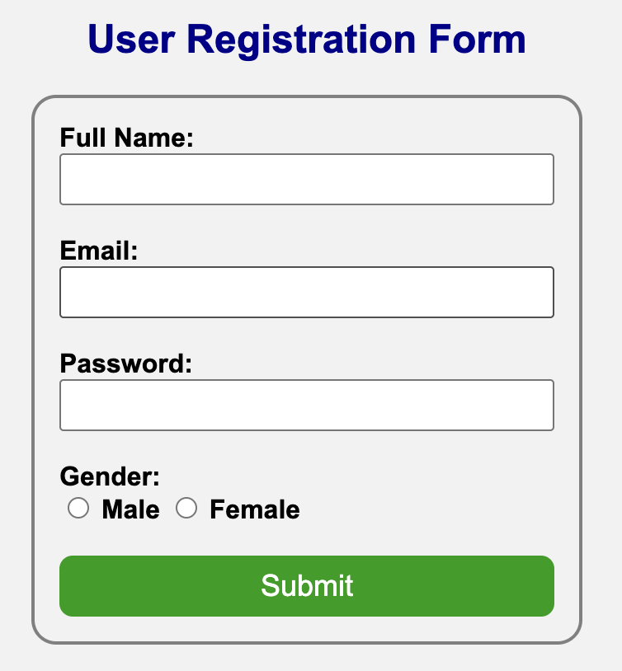

6. Output:
The output is a user registration form displayed in a web browser. The page background and heading style are applied using internal CSS, input fields and labels are styled using external CSS, and the submit button is styled using inline CSS.

7. Conclusion:
In this lab work, a user registration form was successfully developed using HTML. Styling was applied using inline, internal, and external CSS. This experiment helped in understanding the practical use, difference, and priority of different CSS methods used in web development.

I have to print below pages….

5. Source Code:

HTML File (registration.html)

<html>

<head>
<title>User Registration Form</title>

<!-- Internal CSS -->
<style>
body {
background-color: #f2f2f2;
font-family: Arial;
}

form {
width: 300px;
margin: auto;
display: flex;
flex-direction: column;
border: 2px gray solid;
padding: 15px;
border-radius: 15px;
}

h2 {
text-align: center;
color: darkblue;
}
</style>

<!-- External CSS -->
<link rel="stylesheet" href="style.css">
</head>

<body>
<h2>User Registration Form</h2>

<form>
<label>Full Name:</label>
<input type="text" name="name"><br>

<label>Email:</label>
<input type="email" name="email"><br>

<label>Password:</label>
<input type="password" name="password"><br>

<label>Gender:</label>
<div>
<input type="radio" name="gender" id="maleRadio">
<label for="maleRadio">Male</label>
<input type="radio" name="gender" id="femaleRadio">
<label for="femaleRadio">Female</label>
</div><br>

<!-- Inline CSS -->
<button
style="background-color: rgb(6, 157, 6); color: white; padding: 8px; font-size: 18px; border-radius: 8px; border: none;">
Submit
</button>
</form>
</body>

</html>

External CSS File (style.css)

input {
padding: 6px;
}

label {
font-weight: bold;
}

Screenshort:



